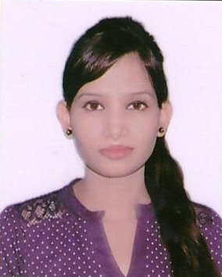  Contact No:-9643790234  Email: ID:-renurshantal@gmail.com  renushantal234@gmail.com  Permanent Address:-  House no- 5271, 115/6, Sant Nagar, Delhi -110084  Personal Data:  DOB:- 14th May, 1990  Sex:- Female  Nationality:- Indian  Marital Status: -Single  Father Name: -  Mr. Hakikat Rai  Languages Known:  English  Hindi | Renu Kumari  Objectives  Career statement: Looking for a organization where I can utilize my maximum efforts to make my progress as well as the firms progress.  Profile Summary  - A multitalented and dynamic person having degree in computer application  - Expert in listening and resolving problem.  - Proficient in delivering high quality result  - Possess exceptional communication skill with an analytical bent of mind to grasp new concept easily and quickly  Academia  - Certification in Tally ERP 9 & Advance excel in 2016  - Bachelor of Computer Application from Indira Gandhi National Open University in 2013  - X from C.B.S.E in 2006  - XII from C.B.S.E in 2008  Technical skills  - Well versed with MS office( MS word, MS excel, MS PowerPoint)  - Advance excel( hlookup, vlookup, financial function, database function, data validations, goal seek)  - Internet savvy  Work Experience  - Currently working with Jindal Infra Solutions Limited as a e commerce executive  - Having 6 month experience with vertex bpo as a customer care executive.  - Having 4 month experience with jindal intellicom as customer support executive.  Strength_________________________________________________________  - Endowed with a passion for winning as evinced through demonstrated excellence in the academic & extracurricular areas.  - Smart Working, Sufficient communicating skills, Keen to learn, Sincere & obedient  - Quick learner, Hard working, positive attitude with strong analytical.
Hobbies

- Listening music.
- Dancing.

Declaration

I confirm that the information provided by me is true to the best of my knowledge and belief.

Signature
(Renu kumari)
Date : 24/10/ 2016

